Reactjs E-commerce Application Project

- GitHub: https://github.com/vkeshwam1/devops-build
- Deployed site: http://3.91.38.48
- DockerHub dev: vkeshwam1/dev
- DockerHub prod: vkeshwam1/prod
- Monitoring: http://3.91.38.48:3001

Docker:
cd ~/devops-build

cat > Dockerfile << 'EOF'
FROM nginx:alpine

COPY build/ /usr/share/nginx/html

EXPOSE 80

CMD ["nginx", "-g", "daemon off;"]
EOF
cat > docker-compose.yml << 'EOF'
version: '3.8'

services:
app:
image: vkeshwam1/dev:latest
ports:
- "80:80"
restart: always
EOF
cat > build.sh << 'EOF'
#!/bin/bash
set -e

BRANCH=$(git rev-parse --abbrev-ref HEAD)
BUILD_NUM=${BUILD_NUMBER:-local}

if [ "$BRANCH" = "master" ]; then
IMAGE="vkeshwam1/prod:$BUILD_NUM"
else
IMAGE="vkeshwam1/dev:$BUILD_NUM"
fi

echo "Building image: $IMAGE"
docker build -t $IMAGE .
docker tag $IMAGE ${IMAGE%:*}:latest
echo "Build complete: $IMAGE"
EOF
chmod +x build.sh

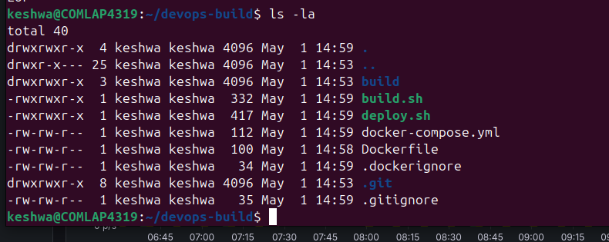

https://github.com/vkeshwam1/devops-build.git

223.181.105.70 EC2

# Check if key exists
ls /tmp/deploy-key.pem 2>/dev/null && echo "Key found!" || echo "Key not found"

# If not found, create it directly
sudo mkdir -p /var/lib/jenkins/.ssh

# Copy the existing trend-app-key content to jenkins
sudo cp ~/.ssh/authorized_keys /tmp/check.txt
ls ~/.ssh/
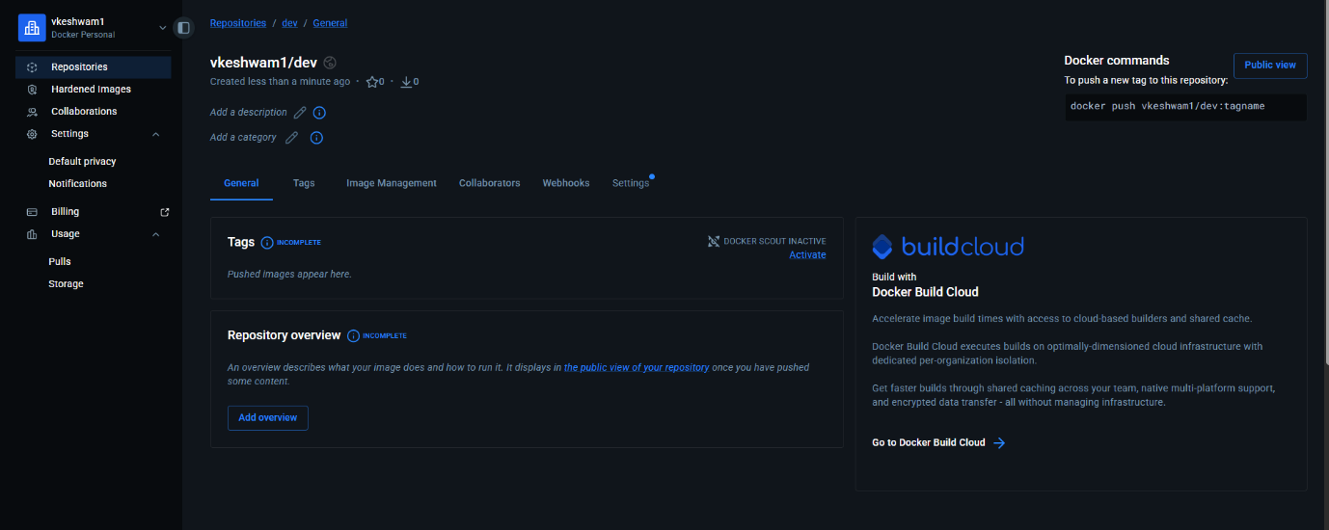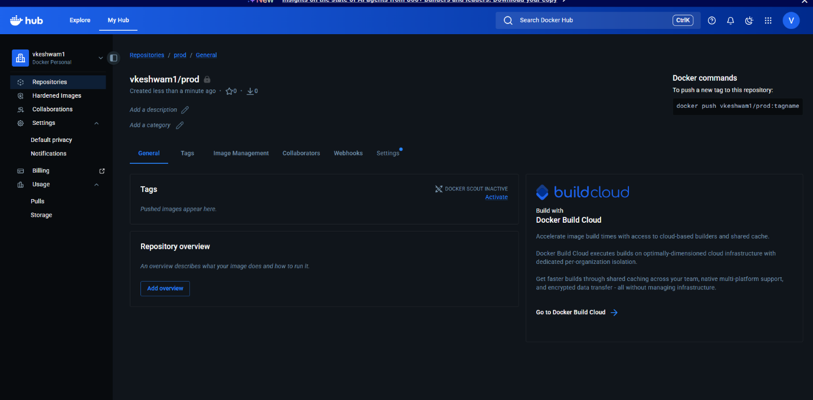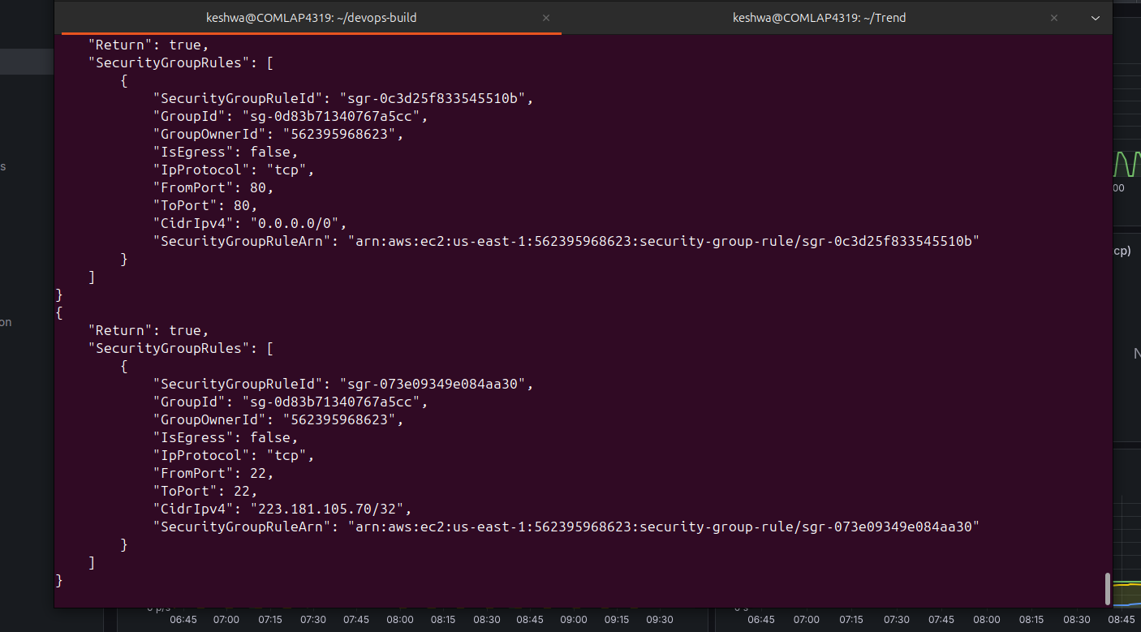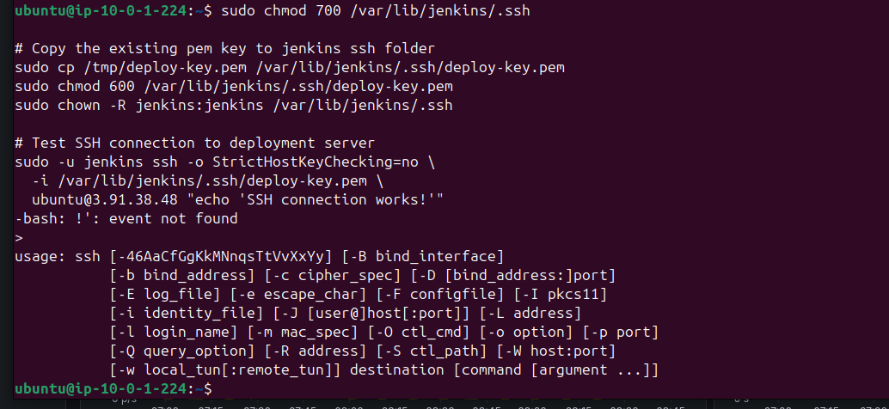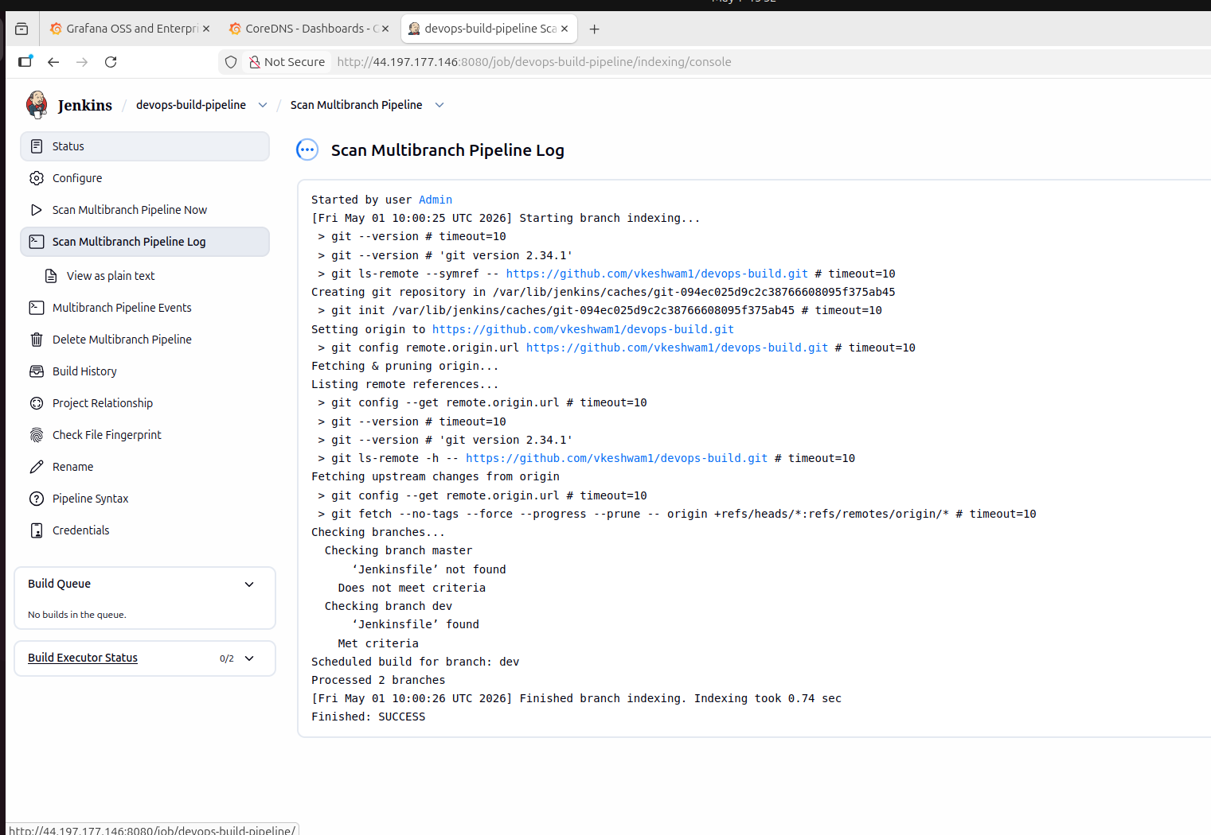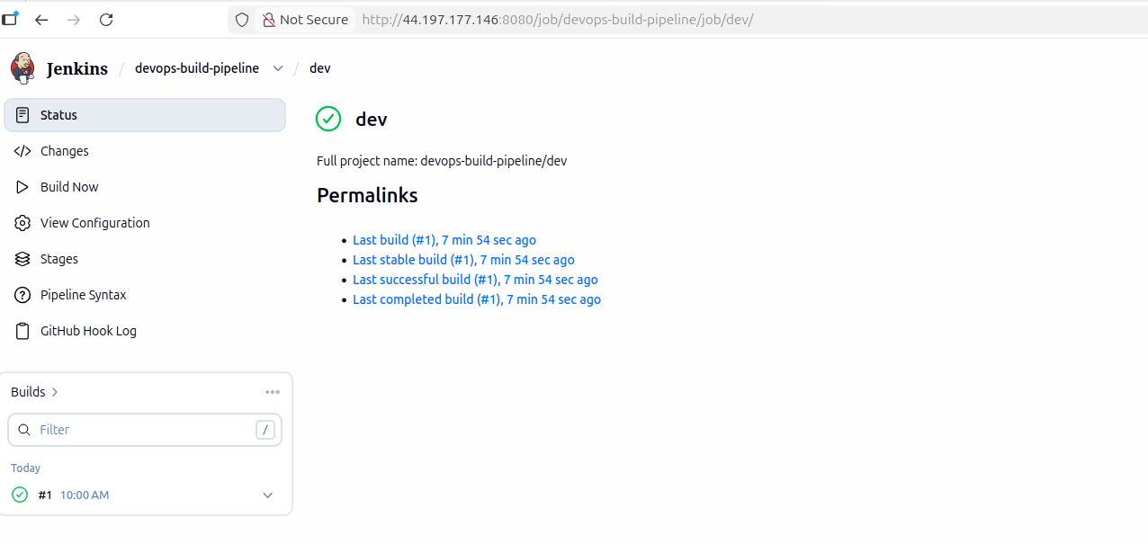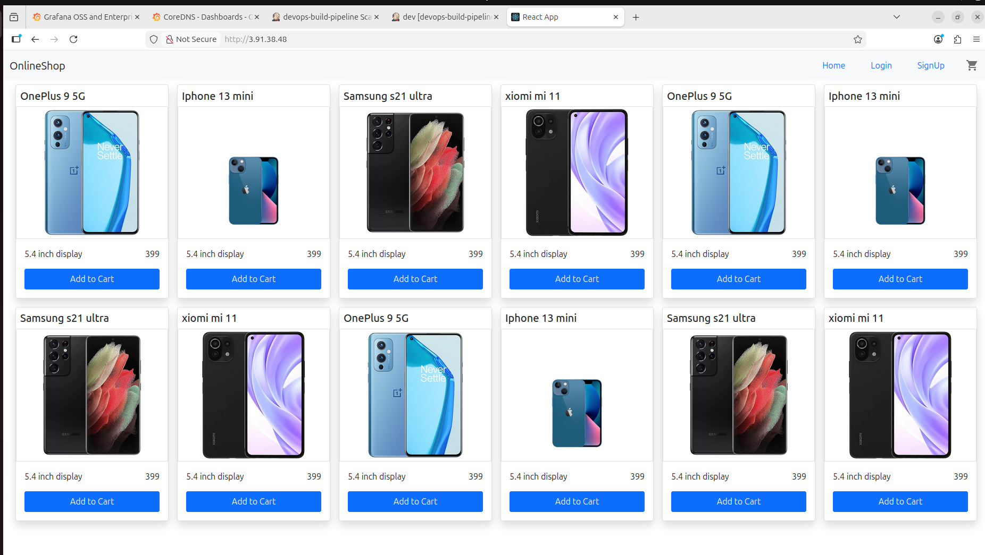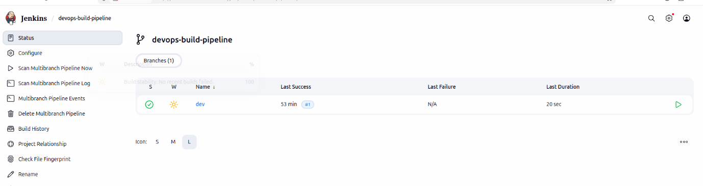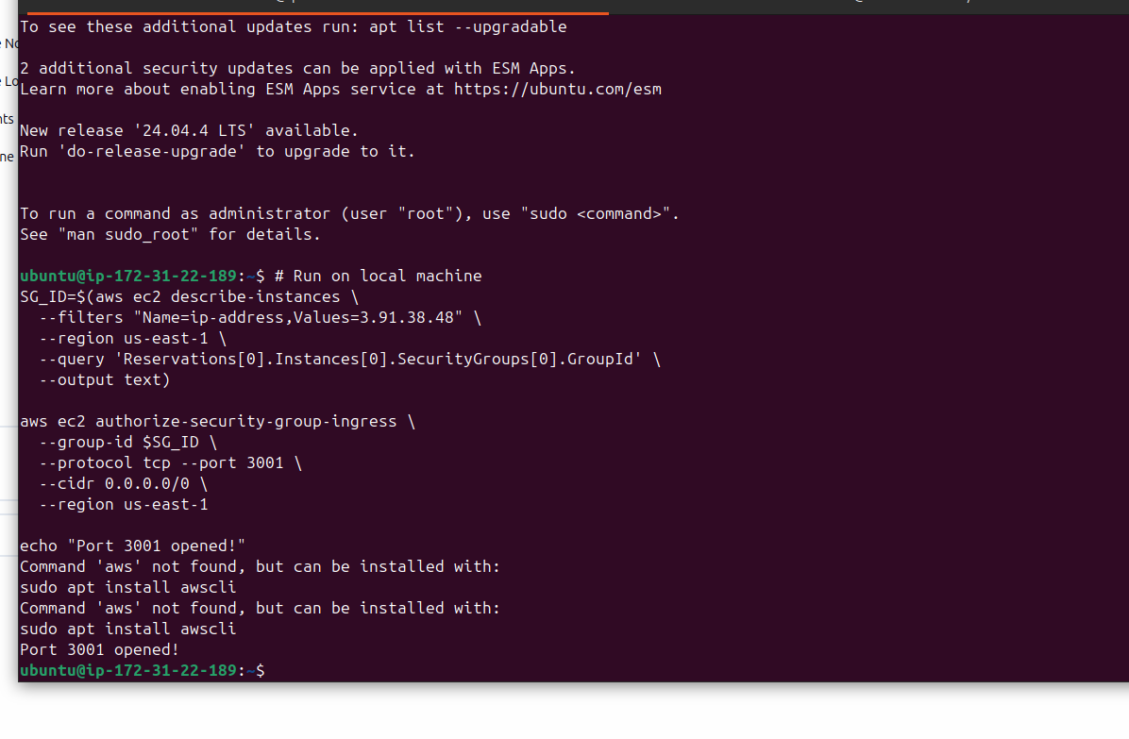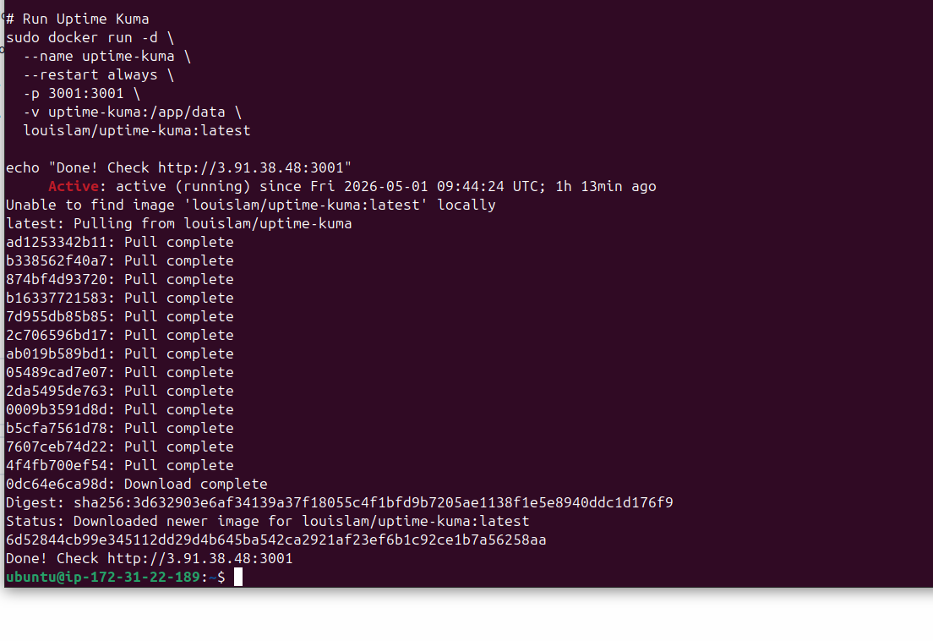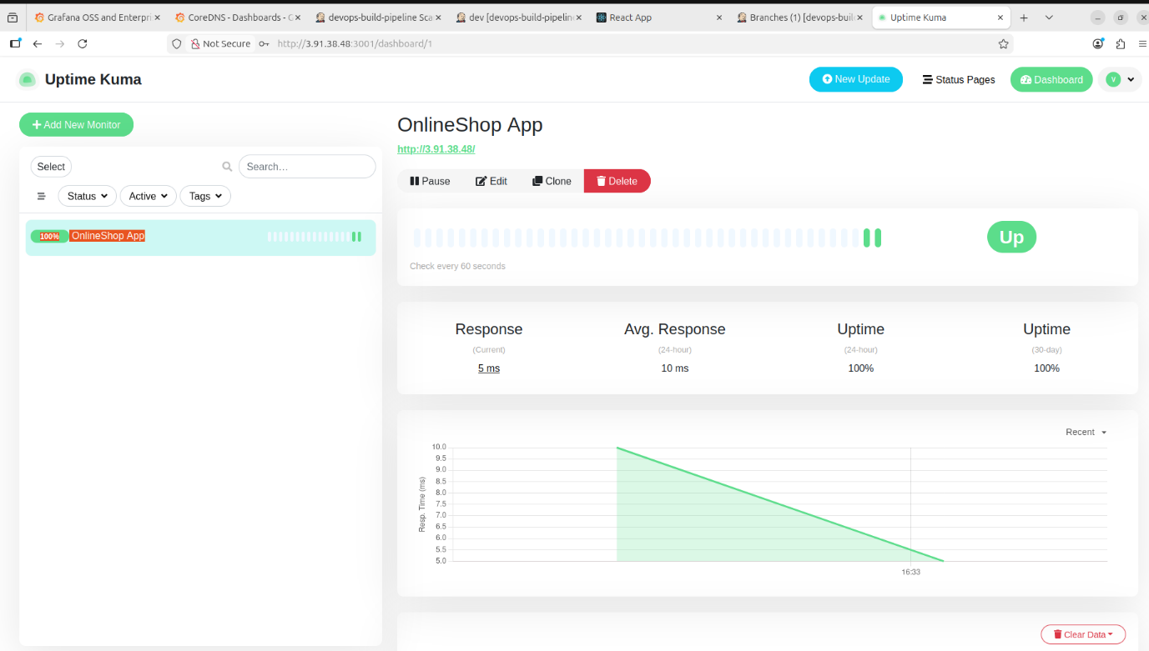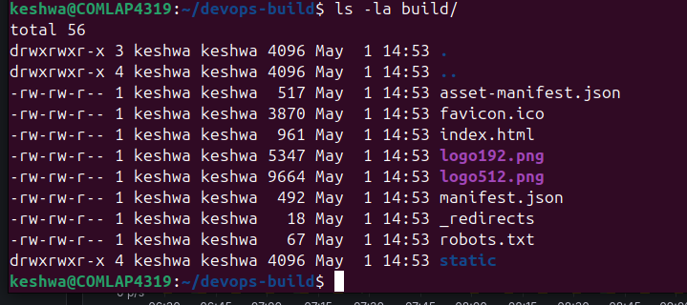
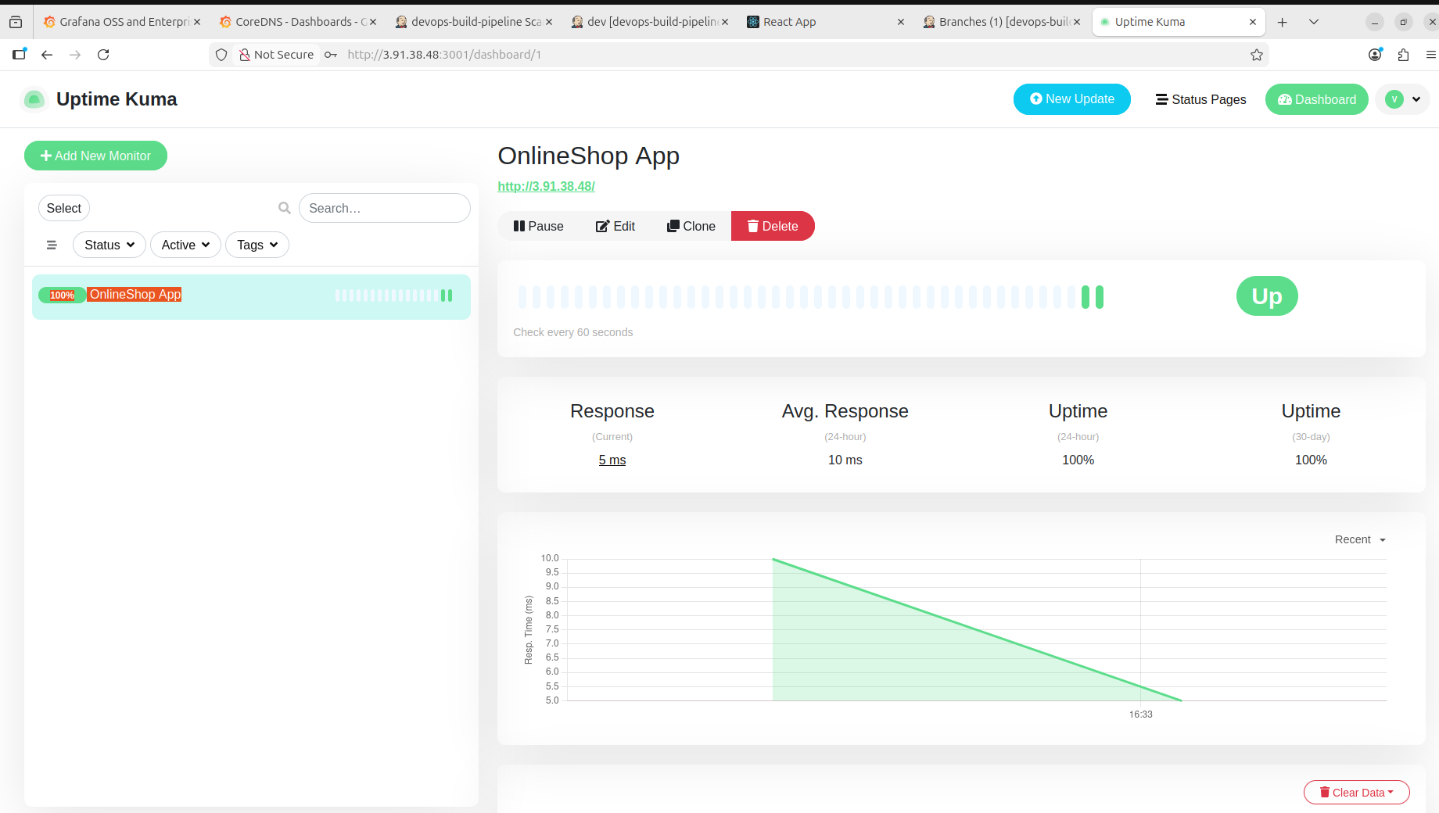

Component | Status | Details
GitHub repo | ✅ | github.com/vkeshwam1/devops-build
Branches | ✅ | dev + master
Dockerfile | ✅ | nginx serving on port 80
docker-compose.yml | ✅ | Done
build.sh | ✅ | Done
deploy.sh | ✅ | Done
DockerHub dev | ✅ | vkeshwam1/dev (public)
DockerHub prod | ✅ | vkeshwam1/prod (private)
Jenkins Pipeline | ✅ | Multibranch — dev build SUCCESS
AWS EC2 t2.micro | ✅ | 3.91.38.48
App Live | ✅ | http://3.91.38.48
Monitoring | ✅ | Uptime Kuma — 100% uptime

Submission details:
- GitHub: https://github.com/vkeshwam1/devops-build
- Deployed site: http://3.91.38.48
- DockerHub dev: vkeshwam1/dev
- DockerHub prod: vkeshwam1/prod
- Monitoring: http://3.91.38.48:3001

